**What identifier should be specified in the "Депозитарий владельца" (Holder's Depository) section in disclosure of a trustee client?**

The identifier of the depository where the securities of the disclosed trustee are held: if the securities are held in a securities account at NSD, the identifier of NSD should be specified, otherwise the identifier of another nominee holder should be specified.

**What identifier should be specified in the "Депозитарий владельца" (Holder's Depository) section in disclosure of a owner client?**

The identifier of the depository where the securities of the disclosed owner are held, i.e. the identifier of the lower level nominee holder.

**If the client is a citizen of another country (not the Russian Federation), what type of document should be selected to fill in information about his/her passport in the sections Identity Documents and Individuals' Codes?**

If none of the types of identification document available in the format is suitable, then 00 - Other should be used, adding a description of the document in the field "Description of type - Other".

**What should be indicated in the new format disclosure in the "Код статуса налогоплательщика" (Taxpayer Status Code) field if such status of the disclosed person is unknown?**

Valid field values:  
1 - Tax resident of the Russian Federation  
2 - Tax non-resident of the Russian Federation

**Recommendations for independent validation of messages generated in the client's own software**

Messages should be validated against the template specified in the DISCLOSURE_REQUEST/information_indicator/disclosure_template field or in the "Шаблон списка" (List Template) field of the "Information" block of the corresponding collection (corporate action type DSCL).

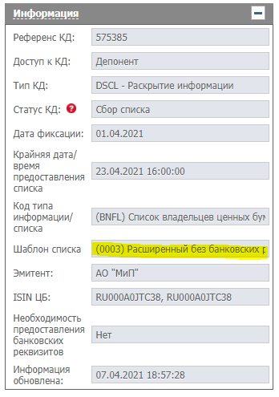

To validate self-created XML, it is recommended to use Altova XML Spy, which has built-in tools for validating XML against the XSD schema.

**Where are the new formats available?**

The new formats are published on the SRO NFA website in the section ВНУТРЕННИЕ СТАНДАРТЫ (INTERNAL STANDARDS), in the form of an [Appendix to the Internal Standard Formats of Electronic Interaction of Registrars with Nominee Holders and Central Securities Depository of the Self-Regulatory Organisation National Financial Association](https://new.nfa.ru/upload/iblock/b62/Formaty_vzaimodeystviya_3.rar) (xsd-schemes).

**How can one distinguish a request from the registrar using the new format from a request using the old format?**

Requests in the new format come as xml messages of DISCLOSURE_REQUEST type, report form code GS61N.

**Which tag specifies the file attached to the disclosure with information about the beneficial persons, in the case of account type DEPR.**

Depositary receipt holders can be specified as an attached file in REGISTER_OF_SHAREHOLDERS_V02/register_list/shareholder/beneficiary/attch block if REGISTER_OF_SHAREHOLDERS_V02/register_list/shareholder/party_account_type/party_account_type_code = DEPR (i.e. In case of depositary programmes depo account).

**How to send large lists (pagination)?**

Multi-page lists are sent as multiple REGISTER_OF_SHAREHOLDERS_V02 messages with the same REGISTER_OF_SHAREHOLDERS_V02/pagination/register_list_id value.  
REGISTER_OF_SHAREHOLDERS_V02/pagination/page_total means the total number of pages in the list (how many messages should come), REGISTER_OF_SHAREHOLDERS_V02/pagination/page means the number of the current page.

**How have the requirements for completeness of owner disclosures changed? To what extent are they mandatory?**

The requirements for completeness and scope of disclosed information are described in the templates that can be found in the [Guidelines available on the NFA SRO website](https://new.nfa.ru/upload/iblock/a5e/MetodicheskieMaterialy.zip).

**Is it correct to state that trustee details should be included in response to any type of request, and that trustor details should be added only for requests about beneficial persons?**

Yes, in case of disclosure via the Web-client and there is information on beneficiaries in the Reference List, it will be included in the list message only if it is required by the list type and template.

**NSDirect (CA Web-client)**

**If different employees of the company make disclosures for different accounts, should each of these disclosures be sent as a new disclosure or as a further disclosure?**

If the disclosures are made for different securities accounts at NSD, they do not need to be sent as additional disclosures as the lists for each securities account at NSD are processed separately. In case of one securities account, the first disclosure is sent as a new disclosure and the rest as additional disclosures.

**Can I use the "Клиенты" (Clients) directory to disclose information or do I need to add information to the "Клиенты для сбора списков" (Clients for Collecting Lists) directory?**

It is not possible to use the Clients directory to create messages with the list for a type DSCL CA: you must fill in a new Clients to the "Клиенты для сбора списков" (Clients for Collecting Lists) directory or upload ready-made messages with the list of persons in xml format.

**If an error appears when saving a client details form in the "Клиенты для сбора списков" (Clients for Collecting Lists) directory, how can I understand which field it refers to?**

After clicking the "Сохранить" (Save) button, if an error is detected, an error message appears in the left menu,

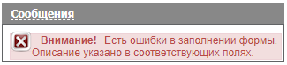

and the erroneously filled fields are highlighted with a red frame.

https://www.nsd.ru/upload/img/wkd2.png

**What type of document should be selected in the "Идентификационные документы" (Identification Documents) section if it is necessary to specify non-resident's TIN, OTHR - TIN or OTHR - Other?**

OTHR - Other (or 00 - Other" in case of an individual) by adding a description of the document in the "Описание типа Прочее" (Description of type Otherfield).

**Procedure for additional disclosure/replacement of information about a person exercising rights under securities for the benefit of other persons.**

If a person exercising rights in securities for the benefit of others has already been disclosed on the primary list but the beneficial owners have not been named, you may disclose the beneficial owners by:  
1 - resending the entire list in a message using the NEWM New Message function;  
2 - adding the beneficiaties details to the Client Details Form in respect to the client to be disclosed, and then creating a message with the AMND Additional Disclosure function,  
selecting the person whose information is being replaced from the "Выберите лицо для исключения из списка" (Select a Person to Remove from the List) tab,  
and selecting the same person on the "Выберите лицо для включения в список" (Select Person to Include in List) tab.

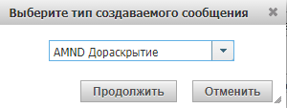

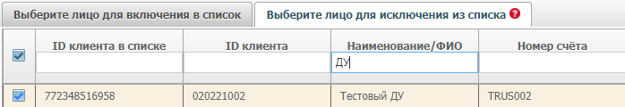

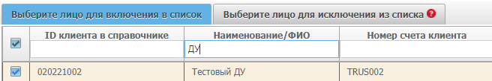

The steps in clause 2 above allow you to manage the replacement of information for any person whose information is to be replaced on the list.

**Limit on message size when uploading via web client Additional disclosure if the primary list message is large.**

If you upload a message larger than 10,000 people, the Web-Client splits the message into parts of 10,000 people each. To create an additional disclosure, you can upload a new xml message using the AMND message function, or create an additional disclosure from the Web-Client using the "Добавить сообщение со списком лиц" (Add Message with List of Persons)https://www.nsd.ru/upload/img/wkd6.png or "Добавить сообщение со списком лиц без использования справочника клиентов" (Add Message with List of Persons Without using the Client Directory)https://www.nsd.ru/upload/img/wkd7.png buttons.

**What is the procedure to be followed by a client in case it uploads a large list via the CA Web-client splitting into parts beforehand? Should the client wait for each part to be accepted sequentially?**

The first option is to upload the first part with the NEWM New Message function and all subsequent parts with the AMND Additional Disclosure function. In this case, each part is received sequentially.

The second option is to upload all messages with the NEWM New Message function, using the pagination block: in the pagination/register_list_id field, all parts are assigned a common identifier, in the pagination/page_total field the total number of parts of the list to be loaded is specified, and in the pagination/page field, the sequence number of the current part is specified. Messages with filled pagination block are waiting for all parts to arrive at NSD and are processed simultaneously.

**How to make a disclosure in the case of two securities?**

The first option is to add the balances to the collection for the holders of both securities, then create a message with a list of persons, including the holders of both securities.

[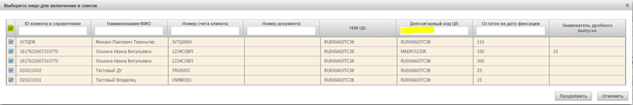](https://www.nsd.ru/upload/img/kd1.png)

The second option is to first include holders of security 1 in the list of persons and send message 1 to NSD when creating a message with a list of persons.

[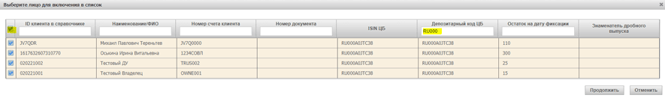](https://www.nsd.ru/upload/img/kd2.png)

After that, use the "Добавить сообщение со списком лиц" (Add Message with List of Persons) button https://www.nsd.ru/upload/img/kd3.png to select the function of the AMND Additional Disclosure message to be created, add holder of security 2, and send message 2 to NSD.

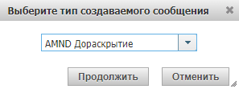

[](https://www.nsd.ru/upload/img/kd5.png)

**How to disclose fractional issues?**

If you need to convert an integer balance to a fractional balance, you can use the "Выделить дробный остаток по счету" (Fractional Account Balance) button,

[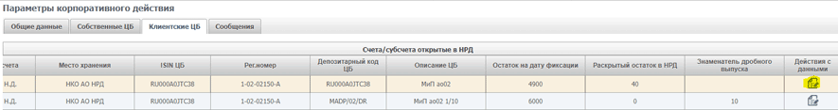](https://www.nsd.ru/upload/img/kd6.png)

by entering the number of integer part securities to be converted to fractional in the line "Укажите количество ценных бумаг основного выпуска в пределах нераспределенного остатка по клиентам" (Specify the Number of Main Issue Securities Within the Unallocated Balance).

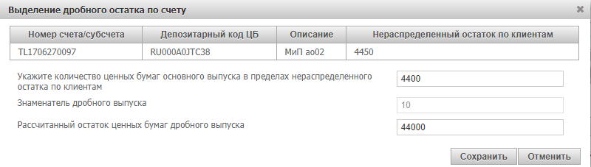

Before:

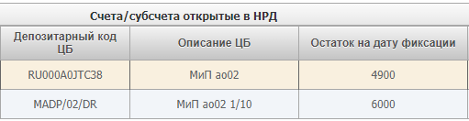

After:

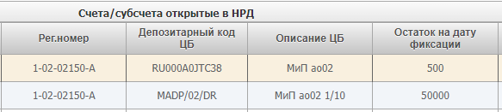

**How to edit or remove the owner from the list?**

By selecting the message needed in "К отправке" (To Send) or "Черновик" (Draft) status, [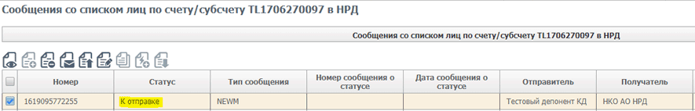](https://www.nsd.ru/upload/img/kd10.png)

you can delete or edit information about the owners included in the selected message in the table "Лица, включенные в сообщение" (Persons included in the message).

[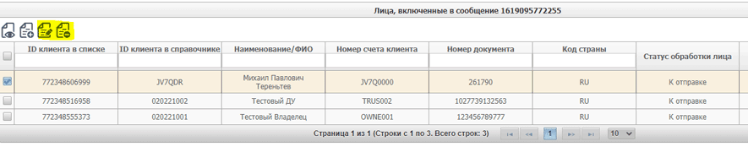](https://www.nsd.ru/upload/img/kd11.png)

**Checking for errors in the disclosure of co-owners and trustees**

If an error about incorrect co-owner/trustee data is received,

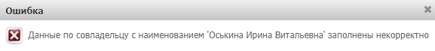

the co-owner/founder should be made available for editing.

[](https://www.nsd.ru/upload/img/kd13.png)

Clicking on the opened form "Ввод окончен" (Entry is finished) will highlight the erroneously filled fields in red; you will have to make corrections and click "Ввод окончен" (Entry is finished).

https://www.nsd.ru/upload/img/kd14.png

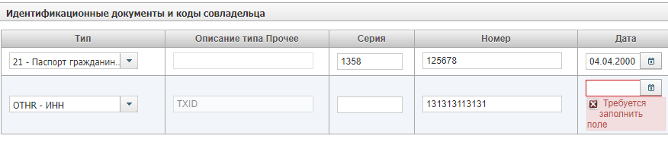

**How to clear cache and cookies in the browser?**

The recommended browser for CA Web-client is Chrome. You can clear cache and cookies through "Настройки и управление браузером” (Settings and Browser Control); select the item "История" (History), select again the menu "История" (History and "Очистить историю посещений" (Clear browsing history) (Ctrl+Shift+Delete); in the opened window, please select the necessary parameters (History, cookies, cache, time range: "с самого начала" (from the beginning)) and click on the "Удалить данные" (Delete data) button.

**What are the specifics of working with the new client directory that will be used in CA Web-client to disclose information in the new format?**

To generate the List in CA Web-client, it will be necessary to first import the owners into the new directory, and then load the balances for these clients into the collection. The new directory supports importing data from a special template; the template and its description can be found at <https://www.nsd.ru/workflow/system/programs/#0-widget-faq-0-10>.

**Will it be possible to automatically unload clients already in LUCH and upload them to the Web-Client when switching to the Web-Client?**

That's not possible, unfortunately. The LUCH directories differ significantly in their content from the directories of the CA Web-client.

**The Excel file (Security_Balance_Import) does not contain the address and bank details of the owner. Do we need to enter all securities owners as clients in the Web-Client beforehand to make the disclosure?**

Yes, it is necessary to load all owners loaded in Security_Balance_Import into the "Клиенты для сбора списков" (Clients for Collecting Lists) directory.

**What is the difference between uploading Excel and xml files?**

Xml is a direct disclosure that can be sent through the CA Web-client, or it can be sent through the Integration Gateway.

Exl templates are created only to work through the CA Web-client for uploading clients to the directory and balances.

**How can I see in the CA Web-client whether a disclosure sent through the Integration Gateway has been accepted or not?**

You can see this by opening the status message and using the associated message number in the List to search the List and see holders accepted/rejected. If the disclosure is made via the File Gateway, neither the disclosure itself nor its statuses will appear in "Сообщениях из других каналов" (Messages from Other Channels); statuses on lists sent from the File Gateway can be found in "Сообщения НРДирект" (NSD Messages).

**Will there be an undisclosed/overdue request?**

Clients need to track the disclosures themselves. It is possible to track them in the CA Web-client using the system tools, but in case of disclosure via File Gateway it is impossible to get an unambiguous visualised status whether the disclosure is exercised or not. In this case, you need analyse reports.

**If errors have been identified for one or more clients and disclosure has failed for them, can I edit the List in "Сообщения из других каналов" (Messages from other channels)?**

No, you cannot.

**Do we need to make a "manual" disclosure for unaccepted clients in this case?**

You can either manually initiate an additional disclosure of unaccepted clients via CA Web-client or by uploading an xml with an additional disclosure attribute (message type AMND), otherwise the previous disclosure will be erased.

**Is it possible to upload a disclosure in an Excel file via CA Web-client without first uploading clients to the directory?**

No. You can either upload the clients first, then the balances in Excel format and generate the disclosure or use an xml file with the disclosure (upload it to CA Web-client or send it via File Gateway).

**Will it be possible to upload the disclosed data in one file for all accounts opened with NSD via the CA Web-client?**

No, the format does not allow generating a disclosure for multiple accounts in one message (the block with the account number cannot be repeated). The disclosure must per account.

**If the number of holders to be disclosed does NOT exceed 10,000, we can upload an Excel file (Security_Balance_Import), but if it does, do we need to upload a multi-page list in xml format?**

You may upload both a ready-made list in xml format and upload balances by owner (in this case, the owners must already be in the "Клиенты для сборов списков" (Clients for Collecting Lists directory)) for any number of owners.

**The User Manuals refer to the template numbers that determine which fields are mandatory. Where can I find all templates?**

Please see the [Guidelines posted on the SRO NFA website](https://new.nfa.ru/upload/iblock/a5e/MetodicheskieMaterialy.zip) or the description of collecting the List on the NSD website above.

**The User Manual states that the "Страна" (Country) field is mandatory if "Нет" (No) is selected in "Идентификационная информация для физического лица известна?" (Is identification information for the individual available?) option, or if the "Адрес" (Address) or "Индекс" (Index) field is filled in. What does this mean?**

If the identification information of the person is unknown, the address must be indicated.

**If bank details for payment of income are available in CA Web-client, but they are not required for the List disclosure, will CA Web-client generate a disclosure without the bank details?**

Yes, if bank details and/or information on persons for whose benefit the rights on securities are exercised are linked to the holder, they will be included in the List only if necessary (if required for collection).

**What does the error "Произошла ошибка при валидации сообщения по шаблону" (An error occurred while validating the message against a template) mean when trying to save a message with a list of holders?**

The error means that the message was not validated against the template used in the collection (the value is displayed in the "Шаблон списка" (List template) row of the "Информация" (Information) table). To correct the error, you need to fill in empty fields that are mandatory or correct values in incorrectly filled in fields.

**Do we need to re-import owner details into the "Клиенты для сбора списков" (Clients for Collecting Lists) directory each time before loading balances into the collection?**

No, the loaded details associated with the holder ID will remain in the directory until it is deleted.

**How can we update holder details previously uploaded to the "Клиенты для сбора списков" (Clients for Collecting Lists) directory?**

To update holder details that has already been added to the directory, simply upload information with the same holder ID as the directory entry. In this case, ***the newly loaded information will completely overwrite the previously saved entry.***

**Is it possible to specify information about several accounts of one client in the "Клиенты для сбора списков" (Clients for Collecting Lists) directory?**

Yes, it is, by adding information about one client several times, with different values of client ID (as client ID is used as a unique identifier of a record in the directory) and account number.

**Is it mandatory to fill in identification documents of a legal entity/individual when loading balances into the collection?**

No, to unambiguously identify a client, a client ID value that matches one of the entries in the "Клиенты для сбора списков" (Clients for Collecting Lists) directory is just needed. If the client ID is not filled in, when loading balances into the collection, the search is performed using the pair of **account number + ID document number.**

**Checks / peculiarities of processing at NSD / other questions**

Can we use LUCH to transit disclosures in new formats?

No, you cannot.

Current documents in new lists:

* DISCLOSURE_REQUEST (list collection request)
* REGISTER_OF_SHAREHOLDERS_V02 (List/individual information)
* DISCLOSURE_CANCELLATION_REQUEST (Request to cancel collection of list/individual information)
* REGISTER_OF_SHAREHOLDERS_STATUS_ADVICE (List/individual information processing status),

LUCH will identify as unknown. This will mean that:

1. A positive transit receipt is sent from LUCH, even if the document is not placed in the LUCH folders and is identified as an unknown document type (i.e., not actually accepted in LUCH);
2. Normally, LUCH stops when it receives a document of unknown type while it is running in the background.

**Payment details in the disclosure under clause 8.6.1: is it necessary to specify payment details of the owner or is it possible to insert details of the nominal holder?**

For template 0012 (except for AUTL list type), it is implied to specify bank details of owners. For other templates with indication of bank details (0002, 0010, 0014), it is up to the Client to choose whether to specify the details.

**Can we replace a disclosure for only one client if needed, or do we need to replace the entire disclosure?**

Yes, each new NEWM message will replace all previously filed disclosures for that collection.

**Will two types of disclosures need to be maintained? If so, for how long?**

Until all registrars have migrated to the new format.

**Is it possible to send one message for one issuer for two issues of securities (ordinary and preferred)?**

Yes, if multiple blocks are completed REGISTER_OF_SHAREHOLDERS_V02/register_list/shareholder/security_balance.

**Will requests for a security be sent for each securities account separately or, in case the same security is recorded in different securities accounts, will there be one request?**

One request will be sent to one depository code (across all accounts and securities involved in the collection).

**What folder in the Integration Gateway will requests and statuses be sent to? How will they be distinguished from other documents?**

The folder with other incoming documents, Q packages.

**Will the format of the MT564 disclosure request change, will it differ across disclosure templates? Will there be information in the request about which template the listing requirements correspond to?**

In MT564 (field 70E ADTX additional information) in Add_info before the additional information will be «Template <код шаблона>. Basis of the request <через запятую коды законодательных и подзаконных актов>» (Template <template code>. Basis of the request <comma separated codes of legislative and bylaws>). There are no other differences from the current format.

**If the bank details of the income beneficiary are required to be provided, how critical would it be if the nominee's account details were disclosed for all listed holders? It is unlikely that a nominee holder will disclose the bank details of ultimate beneficiaries.**

This is not critical for NSD, as there is no relevant verification.  
 However, it may be critical for the initiator of the request, if the purpose of the request was to obtain details of the holders.